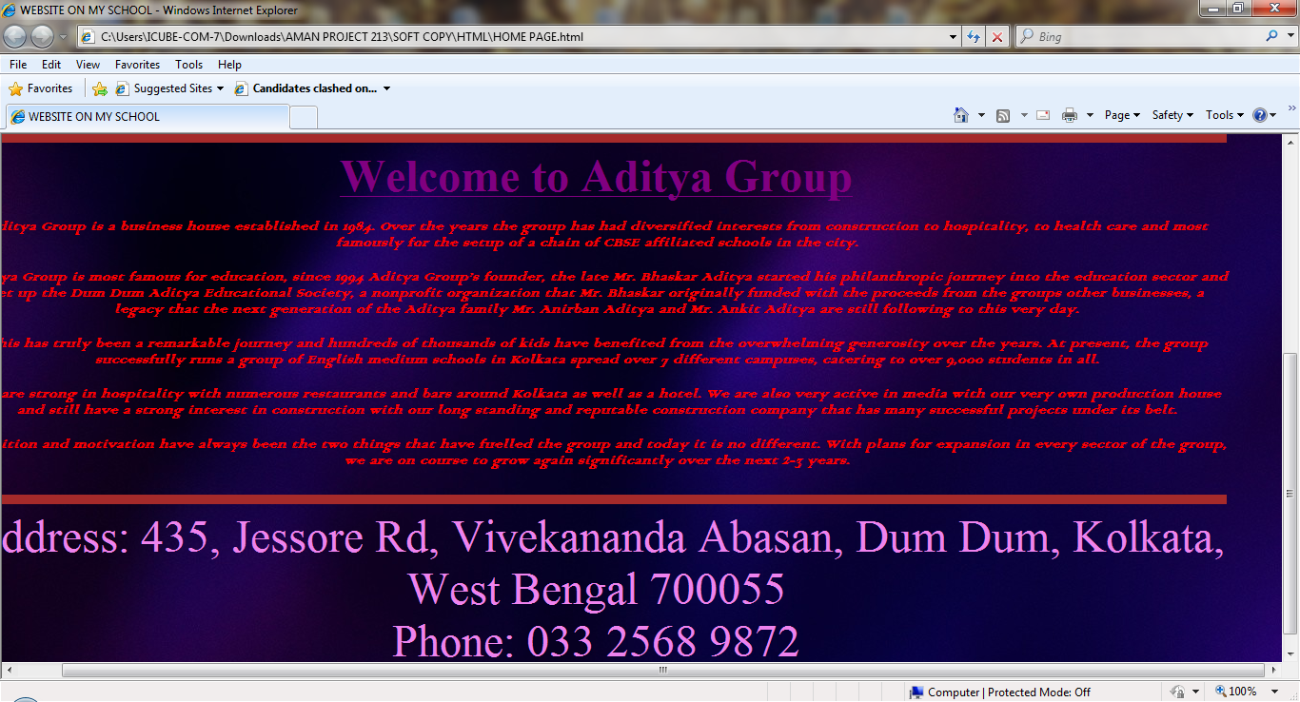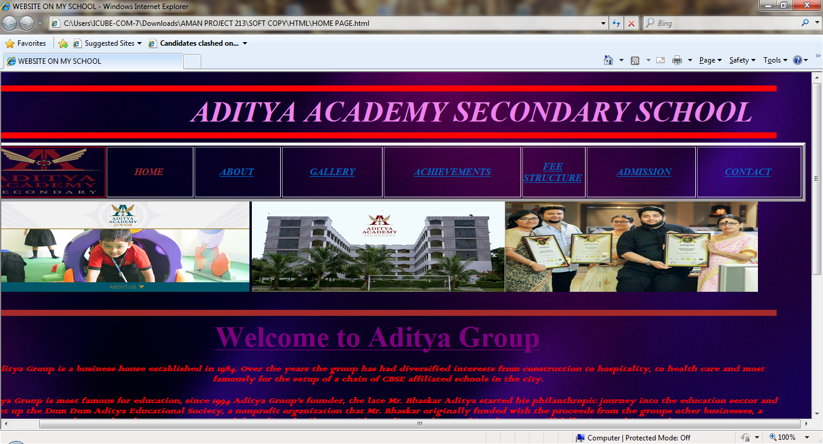

<HTML>

<TITLE>

WEBSITE ON MY SCHOOL

</TITLE>

<HEAD>

<HR SIZE = "10" COLOR = "RED">

<MARQUEE BEHAVIOR = "ALTERNATE">

<FONT FACE= "Bernard MT" SIZE = "24" COLOR = "VIOLET"><B><I>ADITYA ACADEMY SECONDARY SCHOOL</I></B></FONT>

</MARQUEE>

<HR SIZE = "10" COLOR = "RED">

<TABLE BORDER = "5">

<TR BACKGROUND = "170-1707194_abstract-smoke-hd-wallpaper-abstract-colorful-smoke-background.PNG">

<TH BORDERCOLOR = "RED" ><IMG SRC = "SCHOOL LOGO.PNG" HEIGHT = "80" WIDTH = "200"></TH>

<TH ALIGN = "CENTER" ><FONT COLOR = "BROWN"><B><I>&nbsp&nbsp&nbsp&nbsp&nbsp&nbsp&nbsp&nbsp&nbsp&nbsp&nbspHOME&nbsp&nbsp&nbsp&nbsp&nbsp&nbsp&nbsp&nbsp&nbsp&nbsp&nbsp</I></B></FONT></TH>

<TH ALIGN = "CENTER" ><FONT COLOR = "BROWN"><B><I>&nbsp&nbsp&nbsp&nbsp&nbsp&nbsp&nbsp&nbsp&nbsp&nbsp<A HREF = "ABOUT.html">ABOUT</A>&nbsp&nbsp&nbsp&nbsp&nbsp&nbsp&nbsp&nbsp&nbsp&nbsp</I></B></FONT></TH>

<TH ALIGN = "CENTER" ><FONT COLOR = "BROWN"><B><I>&nbsp&nbsp&nbsp&nbsp&nbsp&nbsp&nbsp&nbsp&nbsp&nbsp&nbsp<A HREF = "GALLERY.html">GALLERY</A>&nbsp&nbsp&nbsp&nbsp&nbsp&nbsp&nbsp&nbsp&nbsp&nbsp</I></B></FONT></TH>

<TH ALIGN = "CENTER" ><FONT COLOR = "BROWN"><B><I>&nbsp&nbsp&nbsp&nbsp&nbsp&nbsp&nbsp&nbsp&nbsp&nbsp&nbsp&nbsp<A HREF = "ACHIEVEMENTS.html">ACHIEVEMENTS</A>&nbsp&nbsp&nbsp&nbsp&nbsp&nbsp&nbsp&nbsp&nbsp&nbsp&nbsp</I></B></FONT></TH>

<TH ALIGN = "CENTER"><FONT COLOR = "BROWN"><B><I><A HREF = "FEE STRUCTURE.html">FEE STRUCTURE</A></I></B></FONT></TH>

<TH ALIGN = "CENTER" ><FONT COLOR = "BROWN"><B><I>&nbsp&nbsp&nbsp&nbsp&nbsp&nbsp&nbsp&nbsp&nbsp&nbsp&nbsp&nbsp<A HREF = "ADMISSION.html">ADMISSION</A>&nbsp&nbsp&nbsp&nbsp&nbsp&nbsp&nbsp&nbsp&nbsp</I></B></FONT></TH>

<TH ALIGN = "CENTER" ><FONT COLOR = "BROWN"><B><I>&nbsp&nbsp&nbsp&nbsp&nbsp&nbsp&nbsp&nbsp&nbsp&nbsp&nbsp<A HREF = "CONTACT US.html">CONTACT</A>&nbsp&nbsp&nbsp&nbsp&nbsp&nbsp&nbsp&nbsp&nbsp&nbsp&nbsp</I></B></FONT></TH>

</TR>

</TABLE>

<BODY BACKGROUND = "75913.JPG"><CENTER><IMG SRC = "AAJ_about_us_page-FB.JPG" HEIGHT = "150" WIDTH ="420"><IMG SRC = "Aditya-Academy-Secondary-SchoolBarasat_Logo (1).JPG" HEIGHT = "150" WIDTH = "420"><IMG SRC = "TEACHERS-1.JPG" HEIGHT = "150" WIDTH = "420"></CENTER><P><HR SIZE = "10" COLOR = "BROWN">

<CENTER><A HREF = "Aditya Group _ A Business House Famous For Education and Hospitality.html"><FONT SIZE = "24" FACE "Bernard MT" COLOR = "PURPLE"><B>Welcome to Aditya Group</B></FONT></A></CENTER><p>

<center><FONT COLOR = "RED" FACE = "Colonna MT"><B><I>Aditya Group is a business house established in 1984. Over the years the group has had diversified interests from construction to hospitality, to health care and most famously for the setup of a chain of CBSE affiliated schools in the city.<P>

Aditya Group is most famous for education, since 1994 Aditya Group’s founder, the late Mr. BhaskarAditya started his philanthropic journey into the education sector and set up the Dum Dum Aditya Educational Society, a nonprofit organization that Mr. Bhaskar originally funded with the proceeds from the groups other businesses, a legacy that the next generation of the Aditya family Mr. AnirbanAditya and Mr. AnkitAditya are still following to this very day.<P>

This has truly been a remarkable journey and hundreds of thousands of kids have benefited from the overwhelming generosity over the years. At present, the group successfully runs a group of English medium schools in Kolkata spread over 7 different campuses, catering to over 9,000 students in all.<P>

We are strong in hospitality with numerous restaurants and bars around Kolkata as well as a hotel. We are also very active in media with our very own production house and still have a strong interest in construction with our long standing and reputable construction company that has many successful projects under its belt.<P>

Ambition and motivation have always been the two things that have fuelled the group and today it is no different. With plans for expansion in every sector of the group, we are on course to grow again significantly over the next 2-3 years.</I></B></FONT></center><P><HR SIZE = "10" COLOR = "BROWN">

<CENTER><FONT COLOR = "VIOLET" SIZE = "8">

Address: 435, Jessore Rd, Vivekananda Abasan, Dum Dum, Kolkata, West Bengal 700055<BR>

Phone: 033 2568 9872

</BODY>

</HEAD>

</HTML>

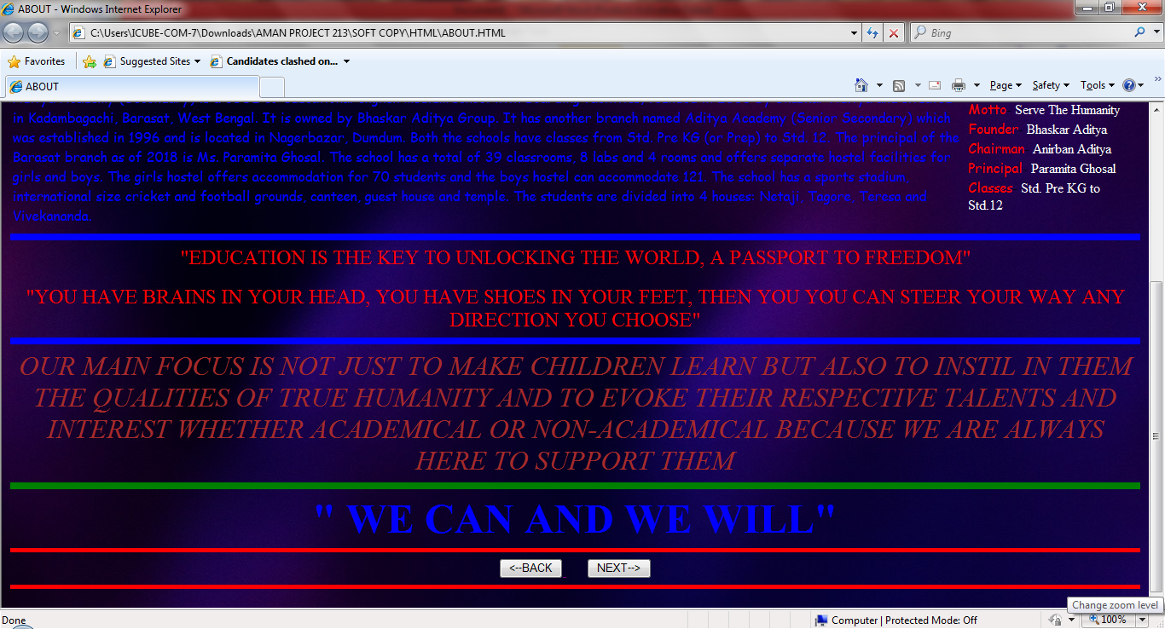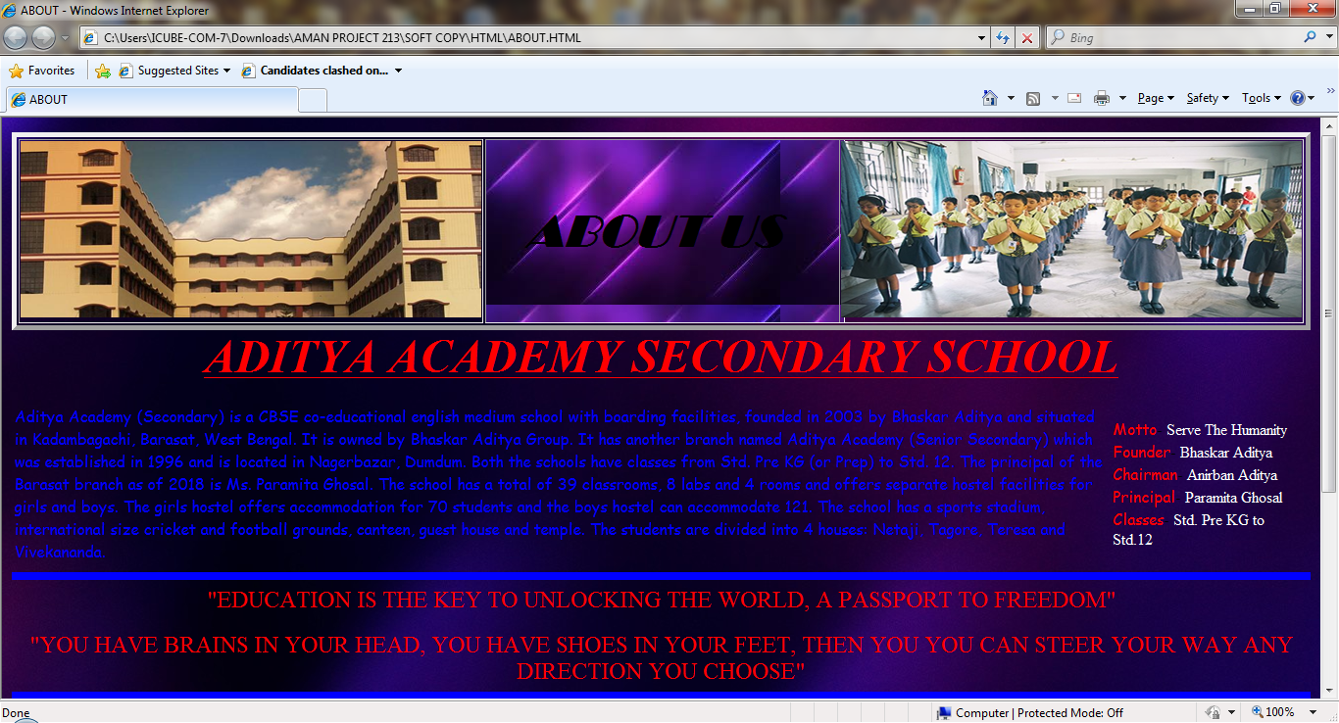

<HTML>

<TITLE>

ABOUT

</TITLE>

<HEAD><CENTER>

<TABLE BORDER = "5">

<TR>

<TH><IMG SRC = "378142.JPG" HEIGHT = "180" WIDTH = "470">

<TH BACKGROUND = "images.JPG" BGCOLOR = "PINK" ALIGN = "CENTER" ><FONT COLOR = "BLACK" FACE = "Broadway" SIZE = "12"><B><I>

&nbsp&nbsp

ABOUT US

&nbsp&nbsp&nbsp

</I></B></FONT></TH>

<TH><IMG SRC = "OUR_VISION-copy.JPG" HEIGHT = "180" WIDTH = "470">

</TR>

</TABLE></CENTER>

</HEAD>

<BODY BACKGROUND = "75913.JPG">

<CENTER><FONT COLOR = "RED" FACE = "Britannic" SIZE = "20"><B><I><U>ADITYA ACADEMY SECONDARY SCHOOL</U></I></B></FONT><CENTER><P>

<TABLE>

<TR><TD>

<FONT COLOR = "BLUE" FACE = "Comic Sans MS">

Aditya Academy (Secondary) is a CBSE co-educational english medium school with boarding facilities, founded in 2003 by BhaskarAditya and situated in Kadambagachi, Barasat, West Bengal. It is owned by BhaskarAditya Group. It has another branch named Aditya Academy (Senior Secondary) which was established in 1996 and is located in Nagerbazar, Dumdum.

Both the schools have classes from Std. Pre KG (or Prep) to Std. 12. The principal of the Barasat branch as of 2018 is Ms. ParamitaGhosal.

The school has a total of 39 classrooms, 8 labs and 4 rooms and offers separate hostel facilities for girls and boys. The girls hostel offers accommodation for 70 students and the boys hostel can accommodate 121. The school has a sports stadium, international size cricket and football grounds, canteen, guest house and temple.

The students are divided into 4 houses: Netaji, Tagore, Teresa and Vivekananda.

</FONT>

</TD>

<TD>

<FONT COLOR = "RED" FACE = "Comic Sans MS">Motto</FONT>- <FONT COLOR = "WHITE">Serve The Humanity</FONT>

<FONT COLOR = "RED" FACE = "Comic Sans MS">Founder</FONT>- <FONT COLOR = "WHITE">BhaskarAditya</FONT>

<FONT COLOR = "RED" FACE = "Comic Sans MS">Chairman</FONT>- <FONT COLOR = "WHITE">AnirbanAditya</FONT>

<FONT COLOR = "RED" FACE = "Comic Sans MS">Principal</FONT>- <FONT COLOR = "WHITE">ParamitaGhosal</FONT>

<FONT COLOR = "RED" FACE = "Comic Sans MS">Classes</FONT>- <FONT COLOR = "WHITE">Std. Pre KG to Std.12</FONT>

</TD>

</TR>

</TABLE>

<HR SIZE = "8" COLOR = "BLUE">

<CENTER><FONT SIZE = "5" COLOR = "RED" FACE = "Cooper">"EDUCATION IS THE KEY TO UNLOCKING THE WORLD, A PASSPORT TO FREEDOM"<P>

"YOU HAVE BRAINS IN YOUR HEAD, YOU HAVE SHOES IN YOUR FEET, THEN YOU YOU CAN STEER YOUR WAY ANY DIRECTION YOU CHOOSE"</FONT><HR SIZE="8" COLOR = "BLUE">

<FONT COLOR = "BROWN" SIZE = "6"><I>

OUR MAIN FOCUS IS NOT JUST TO MAKE CHILDREN LEARN BUT ALSO TO INSTIL IN THEM THE QUALITIES OF TRUE HUMANITY AND TO EVOKE THEIR RESPECTIVE TALENTS AND INTEREST WHETHER ACADEMICAL OR NON-ACADEMICAL BECAUSE WE ARE ALWAYS HERE TO SUPPORT THEM</I></FONT><HR SIZE = "8" COLOR = "GREEN">

<FONT SIZE = "7" COLOR = "BLUE"><B>

" WE CAN AND WE WILL"

</B></FONT><HR SIZE = "5" COLOR = "RED">

<CENTER>

<A HREF = "HOME PAGE.html">

<INPUT TYPE = "BUTTON" NAME = "S1" VALUE = "<--BACK">

</A>

&nbsp&nbsp&nbsp&nbsp&nbsp&nbsp<a href = "GALLERY.html"><INPUT TYPE = "BUTTON" NAME = "S2" VALUE = "NEXT-->"></A><BR></CENTER><HR SIZE = "5" COLOR = "RED">

</BODY>

</HTML>

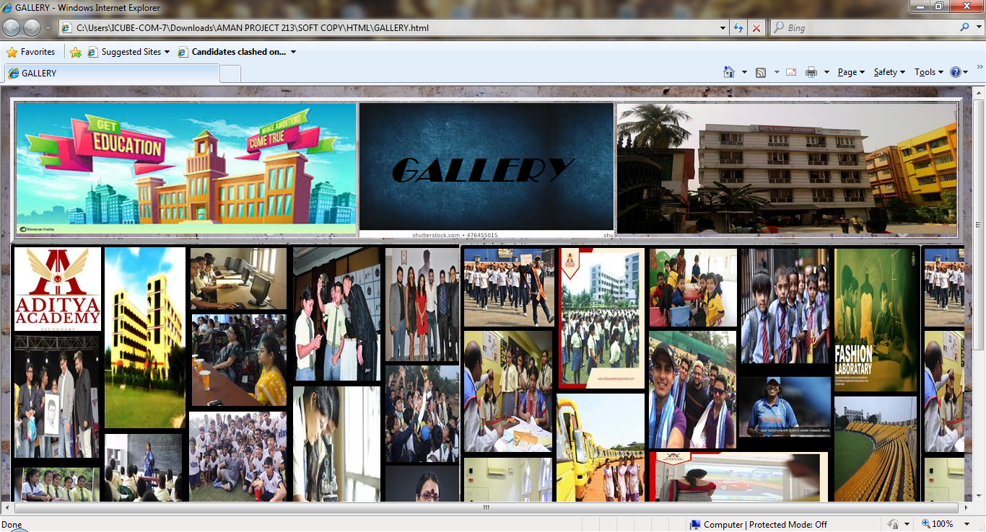

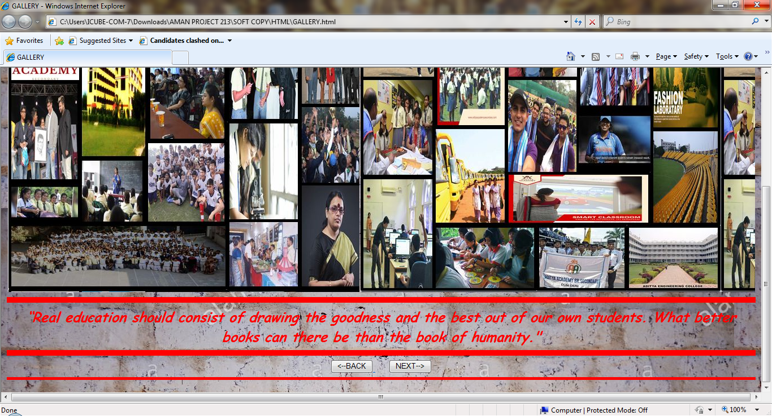

<HTML>

<TITLE>

GALLERY

</TITLE>

<HEAD>

<CENTER>

<TABLE BORDER = "5">

<TR>

<TH><IMG SRC = "images (4).jpg" HEIGHT = "180" WIDTH = "470">

<TH BACKGROUND = "download.JPG" BGCOLOR = "PINK" ALIGN = "CENTER" ><FONT COLOR = "BLACK" FACE = "Broadway" SIZE = "12"><B><I>

&nbsp&nbsp

GALLERY

&nbsp&nbsp&nbsp

</I></B></FONT></TH>

<TH><IMG SRC = "29777-large.JPG" HEIGHT = "180" WIDTH = "470">

</TR>

</TABLE></CENTER>

</HEAD>

<BODY background = "abstract-solid-background-depicting-an-old-white-wall-painted-worn-and-scratched-by-time-T8223W.jpg">

<TABLE BORDER="0">

<TR>

<TH BACKGROUND = "Capture1.jpg">

&nbsp&nbsp&nbsp&nbsp&nbsp&nbsp&nbsp&nbsp&nbsp&nbsp&nbsp&nbsp&nbsp&nbsp&nbsp&nbsp&nbsp&nbsp&nbsp&nbsp&nbsp&nbsp&nbsp&nbsp&nbsp&nbsp&nbsp&nbsp&nbsp&nbsp&nbsp&nbsp&nbsp&nbsp&nbsp&nbsp&nbsp&nbsp&nbsp&nbsp&nbsp&nbsp&nbsp&nbsp&nbsp&nbsp&nbsp&nbsp&nbsp&nbsp&nbsp&nbsp&nbsp&nbsp&nbsp&nbsp&nbsp&nbsp&nbsp&nbsp&nbsp&nbsp&nbsp&nbsp&nbsp&nbsp&nbsp&nbsp&nbsp&nbsp&nbsp&nbsp&nbsp&nbsp&nbsp&nbsp&nbsp&nbsp&nbsp&nbsp&nbsp&nbsp&nbsp&nbsp&nbsp&nbsp&nbsp&nbsp&nbsp&nbsp&nbsp&nbsp&nbsp&nbsp&nbsp&nbsp&nbsp&nbsp&nbsp&nbsp&nbsp&nbsp&nbsp&nbsp&nbsp&nbsp&nbsp&nbsp&nbsp&nbsp&nbsp&nbsp&nbsp&nbsp&nbsp&nbsp&nbsp&nbsp&nbsp&nbsp&nbsp&nbsp&nbsp&nbsp&nbsp&nbsp&nbsp&nbsp&nbsp&nbsp&nbsp&nbsp&nbsp&nbsp&nbsp&nbsp&nbsp&nbsp&nbsp&nbsp&nbsp&nbsp&nbsp&nbsp&nbsp&nbsp&nbsp&nbsp&nbsp&nbsp&nbsp&nbsp&nbsp&nbsp&nbsp

<br><br><br><br><br><br><br><br><br><br><br><br><br><br><br><br><br><br><br><br><br><br><br><br><br><br>

</TH>

<TH BACKGROUND = "Capture2.jpg">

&nbsp&nbsp&nbsp&nbsp&nbsp&nbsp&nbsp&nbsp&nbsp&nbsp&nbsp&nbsp&nbsp&nbsp&nbsp&nbsp&nbsp&nbsp&nbsp&nbsp&nbsp&nbsp&nbsp&nbsp&nbsp&nbsp&nbsp&nbsp&nbsp&nbsp&nbsp&nbsp&nbsp&nbsp&nbsp&nbsp&nbsp&nbsp&nbsp&nbsp&nbsp&nbsp&nbsp&nbsp&nbsp&nbsp&nbsp&nbsp&nbsp&nbsp&nbsp&nbsp&nbsp&nbsp&nbsp&nbsp&nbsp&nbsp&nbsp&nbsp&nbsp&nbsp&nbsp&nbsp&nbsp&nbsp&nbsp&nbsp&nbsp&nbsp&nbsp&nbsp&nbsp&nbsp&nbsp&nbsp&nbsp&nbsp&nbsp&nbsp&nbsp&nbsp&nbsp&nbsp&nbsp&nbsp&nbsp&nbsp&nbsp&nbsp&nbsp&nbsp&nbsp&nbsp&nbsp&nbsp&nbsp&nbsp&nbsp&nbsp&nbsp&nbsp&nbsp&nbsp&nbsp&nbsp&nbsp&nbsp&nbsp&nbsp&nbsp&nbsp&nbsp&nbsp&nbsp&nbsp&nbsp&nbsp&nbsp&nbsp&nbsp&nbsp&nbsp&nbsp&nbsp&nbsp&nbsp&nbsp&nbsp&nbsp&nbsp&nbsp&nbsp&nbsp&nbsp&nbsp&nbsp&nbsp&nbsp&nbsp&nbsp&nbsp&nbsp&nbsp&nbsp&nbsp&nbsp&nbsp&nbsp&nbsp&nbsp&nbsp&nbsp&nbsp&nbsp&nbsp&nbsp&nbsp&nbsp&nbsp&nbsp&nbsp&nbsp&nbsp&nbsp&nbsp&nbsp&nbsp&nbsp&nbsp&nbsp&nbsp&nbsp&nbsp

<br><br><br><br><br><br><br><br><br><br><br><br><br><br><br><br><br><br><br><br><br><br><br><br><br><br>

</TH>

</TR>

</TABLE>

<hr size = "10" color = "red">

<center><bg color = " yellow"><font size = "5" color = "red" face = "Comic Sans MS">

<b><i>“Real education should consist of drawing the goodness and the best out of our own students. What better books can there be than the book of humanity."</i></b></font></center>

<hr size = "10" color = "red">

<CENTER>

<A HREF = "ABOUT.html">

<INPUT TYPE = "BUTTON" NAME = "S1" VALUE = "<--BACK">

</A>

&nbsp&nbsp&nbsp&nbsp&nbsp&nbsp<a href = "ACHIEVEMENTS.html"><INPUT TYPE = "BUTTON" NAME = "S2" VALUE = "NEXT-->"></A><BR></CENTER><HR SIZE = "5" COLOR = "RED">

</BODY>

</HTML>

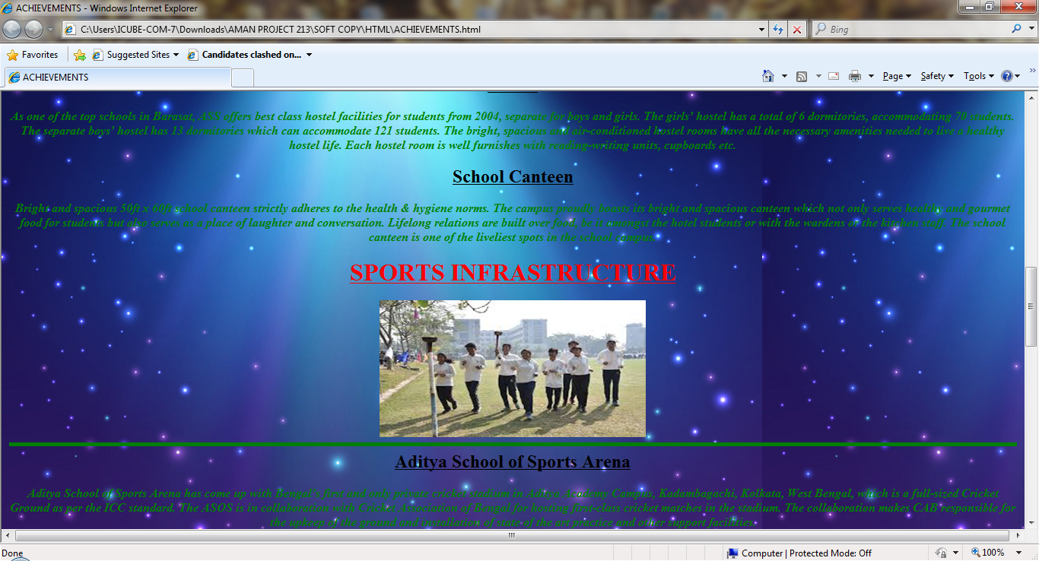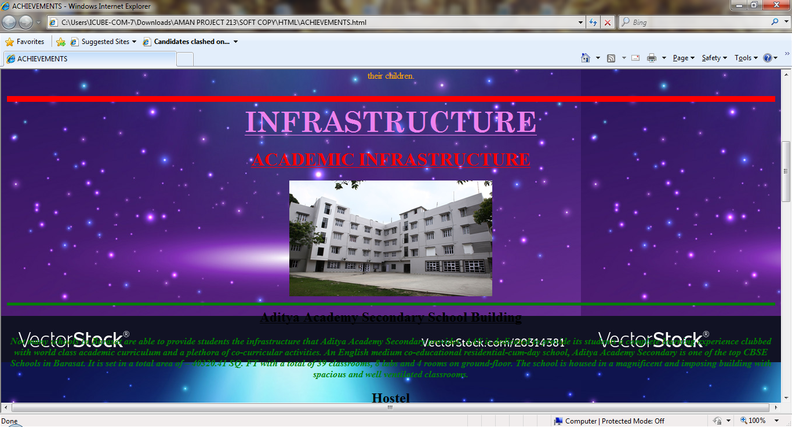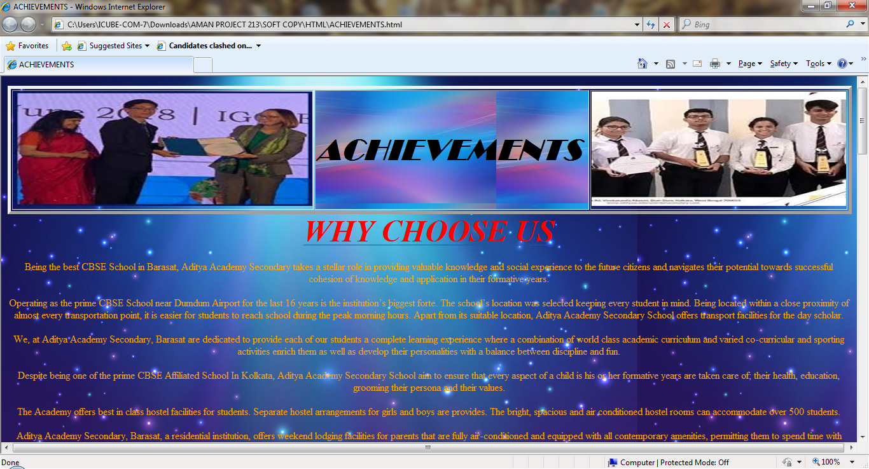

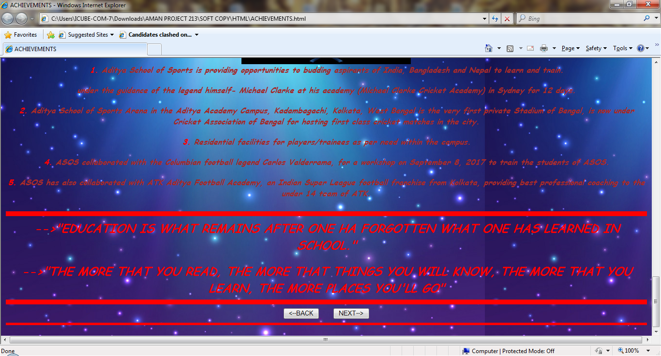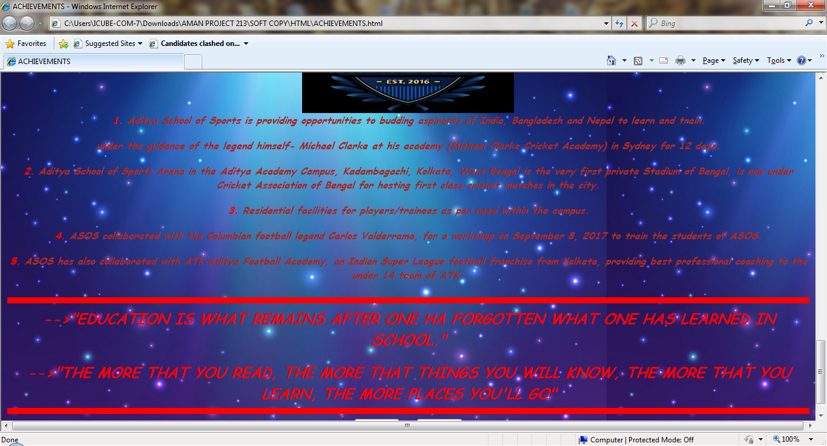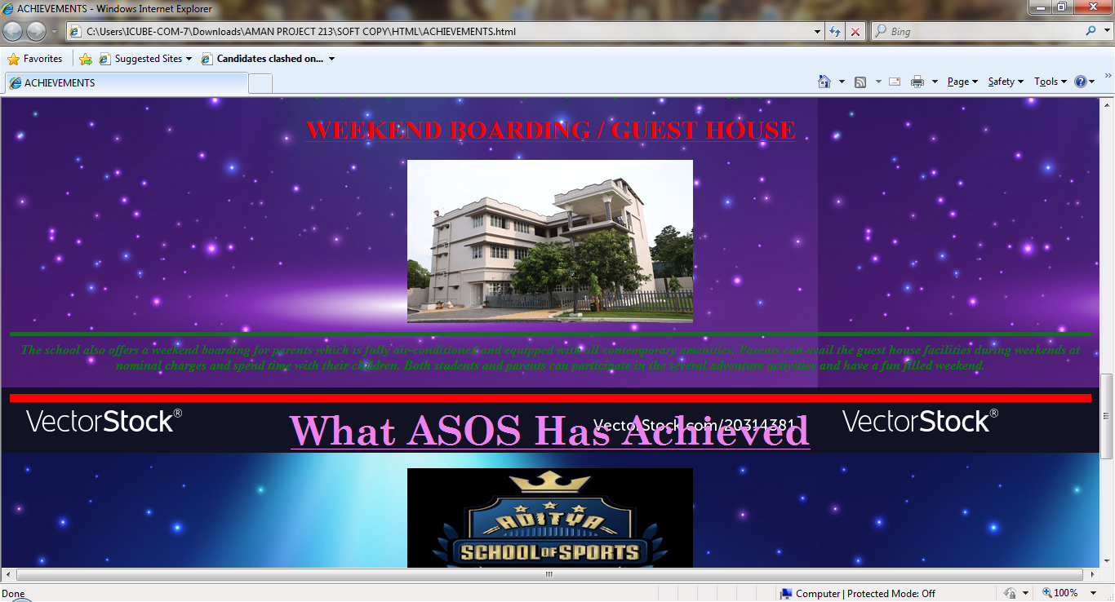

<HTML>

<TITLE>

ACHIEVEMENTS

</TITLE>

<HEAD>

<CENTER>

<TABLE BORDER = "5">

<TR>

<TH><IMG SRC = "images (8).jpg" HEIGHT = "180" WIDTH = "470">

<TH BACKGROUND = "download (3).JPG" BGCOLOR = "PINK" ALIGN = "CENTER" ><FONT COLOR = "BLACK" FACE = "Broadway" SIZE = "12"><B><I>

&nbsp&nbsp

ACHIEVEMENTS

&nbsp&nbsp&nbsp

</I></B></FONT></TH>

<TH><IMG SRC = "images (7).JPG" HEIGHT = "180" WIDTH = "400">

</TR>

</TABLE></CENTER>

</HEAD>

<BODY BACKGROUND = "magic-light-background-shining-background-vector-20314381.JPG">

<CENTER>

<FONT SIZE = "7" FACE = "Cooper" COLOR = "RED" ><B><I><U>

WHY CHOOSE US</U></I></B></FONT><P>

<FONT COLOR = "ORANGE" SIZE = "3" FACE = "Copperplate Gothic">Being the best CBSE School in Barasat, Aditya Academy Secondary takes a stellar role in providing valuable knowledge and social experience to the future citizens and navigates their potential towards successful cohesion of knowledge and application in their formative years.<P>

Operating as the prime CBSE School near Dumdum Airport for the last 16 years is the institution’s biggest forte. The school’s location was selected keeping every student in mind. Being located within a close proximity of almost every transportation point, it is easier for students to reach school during the peak morning hours. Apart from its suitable location, Aditya Academy Secondary School offers transport facilities for the day scholar.<P>

We, at Aditya Academy Secondary, Barasat are dedicated to provide each of our students a complete learning experience where a combination of world class academic curriculum and varied co-curricular and sporting activities enrich them as well as develop their personalities with a balance between discipline and fun.<P>

Despite being one of the prime CBSE Affiliated School In Kolkata, Aditya Academy Secondary School aim to ensure that every aspect of a child is his or her formative years are taken care of; their health, education, grooming their persona and their values.<P>

The Academy offers best in class hostel facilities for students. Separate hostel arrangements for girls and boys are provides. The bright, spacious and air conditioned hostel rooms can accommodate over 500 students.<P>

Aditya Academy Secondary, Barasat, a residential institution, offers weekend lodging facilities for parents that are fully air-conditioned and equipped with all contemporary amenities, permitting them to spend time with their children.<P></FONT></CENTER>

<HR SIZE = "10" COLOR = "RED">

<CENTER><FONT SIZE = "7" COLOR = "VIOLET" FACE = "Century Schoolbook"><B><U>INFRASTRUCTURE</U></B></FONT><P>

<FONT SIZE = "6" FACE = "Gloucester MT" COLOR = "RED"><U><B>ACADEMIC INFRASTRUCTURE</B></U></FONT><P>

<IMG SRC = "Aditya_Academy_Secondary_Barasat_Hostel_4-1.JPG" HEIGHT = "200" WIDTH = "350">

<HR SIZE = "5" COLOR = "GREEN">

<FONT SIZE = "5"><B><U>Aditya Academy Secondary School Building</U></B></FONT><P>

<FONT COLOR = "GREEN" FACE = "Cooper"><B><I>

Not many schools in Barasat are able to provide students the infrastructure that Aditya Academy Secondary provides. AAS is dedicated to provide its students a complete learning experience clubbed with world class academic curriculum and a plethora of co-curricular activities. An English medium co-educational residential-cum-day school, Aditya Academy Secondary is one of the top CBSE Schools in Barasat. It is set in a total area of – 40320.41 SQ. FT with a total of 39 classrooms, 8 labs and 4 rooms on ground-floor. The school is housed in a magnificent and imposing building with spacious and well ventilated classrooms.</I></B></FONT><P>

<FONT SIZE = "5"><B><U>

Hostel</U></B></FONT><P>

<FONT COLOR = "GREEN" FACE = "Cooper"><B><I>

As one of the top schools in Barasat, ASS offers best class hostel facilities for students from 2004, separate for boys and girls. The girls’ hostel has a total of 6 dormitories, accommodating 70 students. The separate boys’ hostel has 13 dormitories which can accommodate 121 students. The bright, spacious and air-conditioned hostel rooms have all the necessary amenities needed to live a healthy hostel life. Each hostel room is well furnishes with reading-writing units, cupboards etc.</I></B></FONT><P>

<FONT SIZE = "5"><B><U>

School Canteen</U></B></FONT><P>

<FONT COLOR = "GREEN" FACE = "Cooper"><B><I>

Bright and spacious 50ft x 60ft school canteen strictly adheres to the health & hygiene norms. The campus proudly boasts its bright and spacious canteen which not only serves healthy and gourmet food for students but also serves as a place of laughter and conversation. Lifelong relations are built over food, be it amongst the hotel students or with the wardens or the kitchen staff. The school canteen is one of the liveliest spots in the school campus.</I></B></FONT><P>

<FONT SIZE = "6" FACE = "Gloucester MT" COLOR = "RED"><U><B>SPORTS INFRASTRUCTURE</B></U></FONT><P>

<CENTER><IMG SRC = "download (4).JPG" HEIGHT = "180" WIDTH = "350"></CENTER>

<HR SIZE = "5" COLOR = "GREEN">

<FONT SIZE = "5"><B><U>

Aditya School of Sports Arena</U></B></FONT><P>

<FONT COLOR = "GREEN" FACE = "Cooper"><B><I>

Aditya School of Sports Arena has come up with Bengal’s first and only private cricket stadium in Aditya Academy Campus, Kadambagachi, Kolkata, West Bengal, which is a full-sized Cricket Ground as per the ICC standard. The ASOS is in collaboration with Cricket Association of Bengal for hosting first-class cricket matches in the stadium. The collaboration makes CAB responsible for the upkeep of the ground and installation of state of the art practice and other support facilities.</I></B></FONT><P>

<FONT SIZE = "6" FACE = "Gloucester MT" COLOR = "RED"><U><B>

WEEKEND BOARDING / GUEST HOUSE</B></U></FONT><P>

<IMG SRC = "Aditya_Academy_Secondary_Barasat_Guest_House_1.JPG" HEIGHT = "200" WIDTH = "350">

<HR SIZE = "5" COLOR = "GREEN">

<FONT COLOR = "GREEN" FACE = "Cooper"><B><I>

The school also offers a weekend boarding for parents which is fully air-conditioned and equipped with all contemporary amenities. Parents can avail the guest house facilities during weekends at nominal charges and spend time with their children. Both students and parents can participate in the several adventure activities and have a fun filled weekend.</I></B></FONT><P>

<HR SIZE = "10" COLOR = "RED">

<FONT SIZE = "7" COLOR = "VIOLET" FACE = "Century Schoolbook"><B><U>What ASOS Has Achieved</U></B></FONT><P>

<CENTER><IMG SRC = "L45oChpF_400x400.JPG" HEIGHT = "180" WIDTH = "350"></CENTER>

<font COLOR = "BROWN" FACE = "Comic Sans MS"><B><I>

<FONT COLOR = "RED">

1.</FONT>Aditya School of Sports is providing opportunities to budding aspirants of India, Bangladesh and Nepal to learn and train.<P>under the guidance of the legend himself- Michael Clarke at his academy (Michael Clarke Cricket Academy) in Sydney for 12 days.<P>

<FONT COLOR = "RED">2.</FONT>Aditya School of Sports Arena in the Aditya Academy Campus, Kadambagachi, Kolkata, West Bengal is the very first private Stadium of Bengal, is now under Cricket Association of Bengal for hosting first class cricket matches in the city.<P>

<FONT COLOR = "RED">3.</FONT> Residential facilities for players/trainees as per need within the campus.<P>

<FONT COLOR = "RED">4.</FONT> ASOS collaborated with the Columbian football legend Carlos Valderrama, for a workshop on September 8, 2017 to train the students of ASOS.<P>

<FONT COLOR = "RED">5.</FONT> ASOS has also collaborated with ATK Aditya Football Academy, an Indian Super League football franchise from Kolkata, providing best professional coaching to the under 14 team of ATK.<P></I></B></FONT></CENTER>

<HR SIZE = "10" COLOR = "RED">

<CENTER><FONT COLOR = "RED" FACE = "Comic Sans MS" SIZE = "5"><B><I>

-->"EDUCATION IS WHAT REMAINS AFTER ONE HA FORGOTTEN WHAT ONE HAS LEARNED IN SCHOOL."<P>

-->"THE MORE THAT YOU READ, THE MORE THAT THINGS YOU WILL KNOW, THE MORE THAT YOU LEARN, THE MORE PLACES YOU'LL GO"</I></B></FONT></CENTER>

<HR SIZE = "10" COLOR = "RED">

<CENTER>

<A HREF = "GALLERY.html">

<INPUT TYPE = "BUTTON" NAME = "S1" VALUE = "<--BACK">

</A>

&nbsp&nbsp&nbsp&nbsp&nbsp&nbsp<a href = "FEE STRUCTURE.html"><INPUT TYPE = "BUTTON" NAME = "S2" VALUE = "NEXT-->"></A><BR></CENTER><HR SIZE = "5" COLOR = "RED">

</BODY>

</HTML>

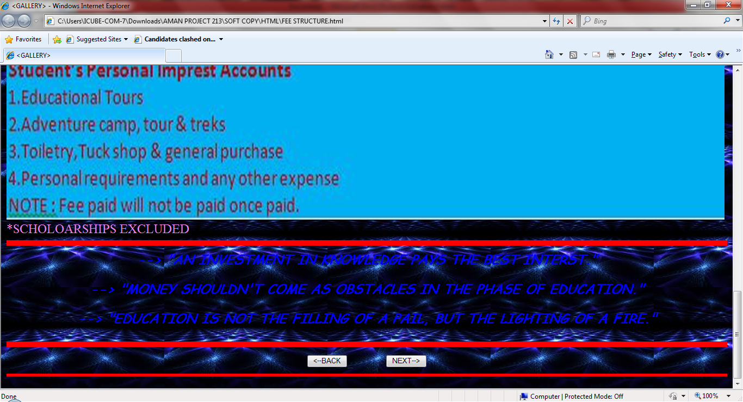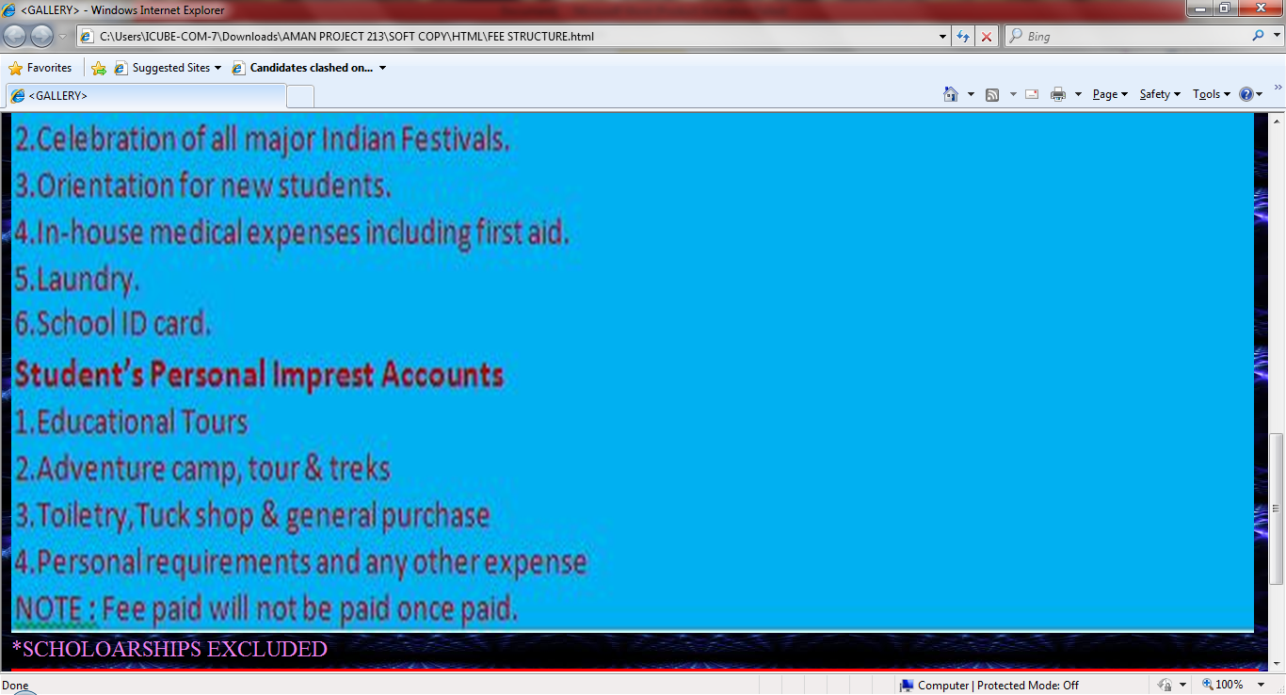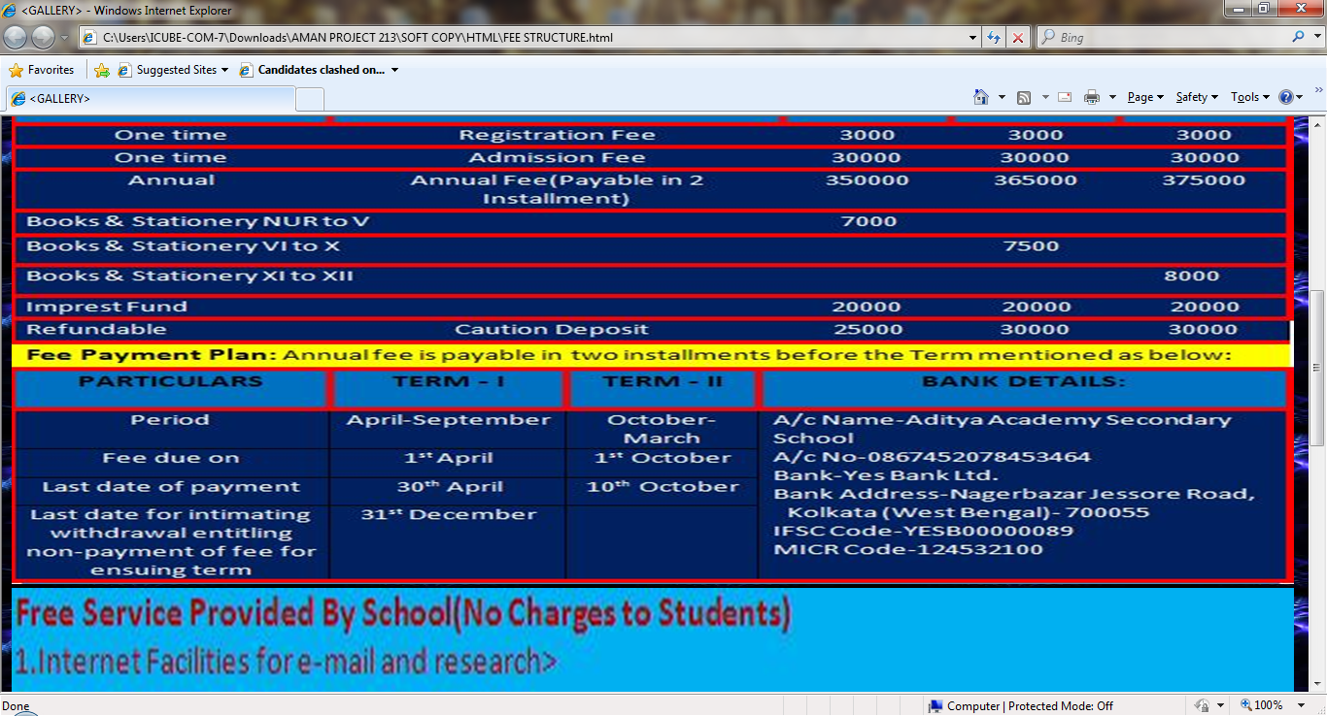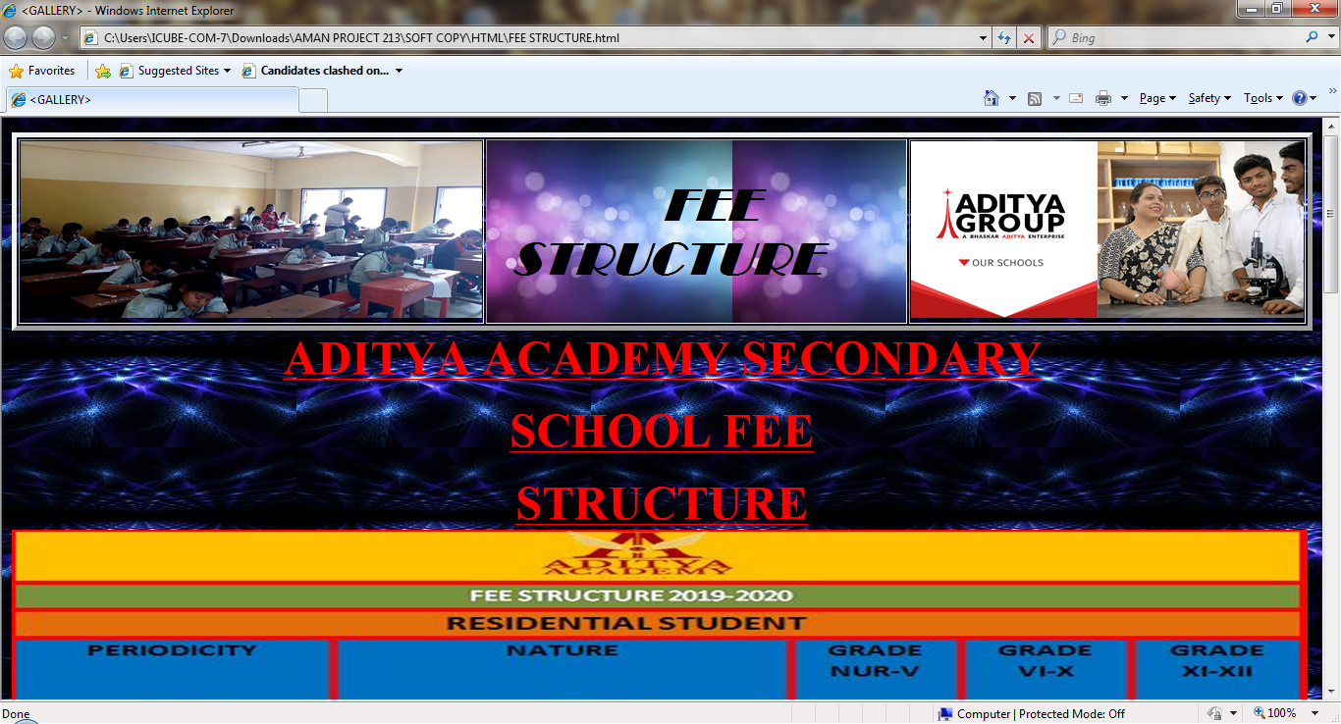

<HTML>

<TITLE>

<GALLERY>

</TITLE>

<HEAD>

<CENTER>

<TABLE BORDER = "5">

<TR>

<TH><IMG SRC = "1.jpg" HEIGHT = "180" WIDTH = "470">

<TH BACKGROUND = "download (5).JPG" BGCOLOR = "PINK" ALIGN = "CENTER" ><FONT COLOR = "BLACK" FACE = "Broadway" SIZE = "12"><B><I>

&nbsp&nbsp

FEE STRUCTURE

&nbsp&nbsp&nbsp

</I></B></FONT></TH>

<TH><IMG SRC = "Our_schools_FB.PNG" HEIGHT = "180" WIDTH = "400">

</TR>

</TABLE></CENTER>

</HEAD>

<BODY BACKGROUND = "images (10).JPG">

<CENTER>

<FONT SIZE = "7" COLOR = "RED" FACE = "Gill sans"><B><U>ADITYA ACADEMY SECONDARY<P> SCHOOL FEE<P>STRUCTURE</U></B></FONT></center>

<imgsrc = "Capture 3.jpg" height = "650" width = "1320">

<imgsrc = "Capture 4.jpg" height = "650" width = "1320">

<FONT SIZE = "5" COLOR = "VIOLET">*SCHOLOARSHIPS EXCLUDED</FONT>

<hr size = "10" color = "red">

<center>

<font size = "5" color = "blue" face = "Comic Sans MS"><B><i>--> "AN INVESTMENT IN KNOWLEDGE PAYS THE BEST INTERST."<P>

--> "MONEY SHOULDN'T COME AS OBSTACLES IN THE PHASE OF EDUCATION."<P>

--> "EDUCATION IS NOT THE FILLING OF A PAIL, BUT THE LIGHTING OF A FIRE."<P>

<hr size = "10" color = "red">

<CENTER>

<A HREF = "ACHIEVEMENTS.html">

<INPUT TYPE = "BUTTON" NAME = "S1" VALUE = "<--BACK">

</A>

&nbsp&nbsp&nbsp&nbsp&nbsp&nbsp<a href = "ADMISSION.html"><INPUT TYPE = "BUTTON" NAME = "S2" VALUE = "NEXT-->"></A><BR></CENTER><HR SIZE = "5" COLOR = "RED">

</body>

</html>

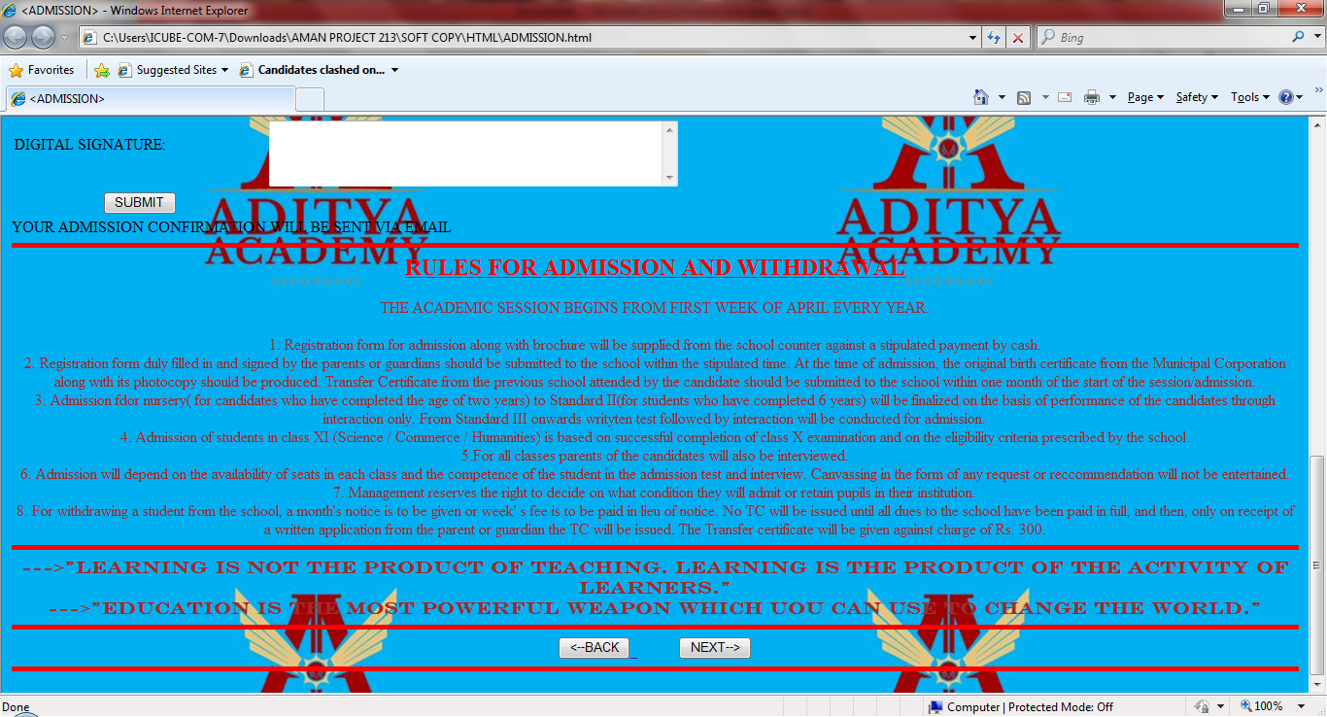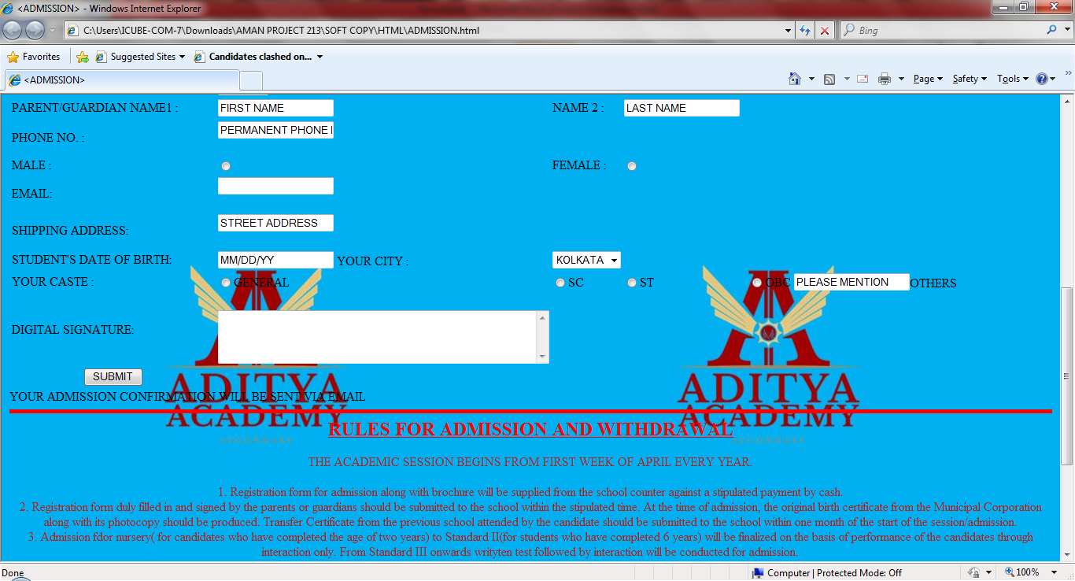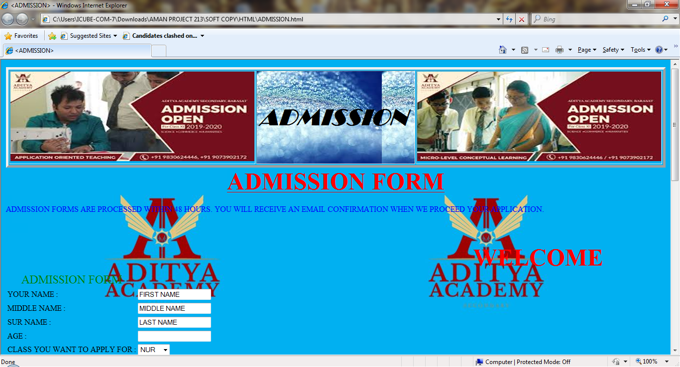

<HTML>

<TITLE>

<ADMISSION>

</TITLE>

<HEAD>

<CENTER>

<TABLE BORDER = "5">

<TR>

<TH><IMG SRC = "images (13).jpg" HEIGHT = "180" WIDTH = "490">

<TH BACKGROUND = "images (11).JPG" BGCOLOR = "PINK" ALIGN = "CENTER" ><FONT COLOR = "BLACK" FACE = "Broadway" SIZE = "12"><B><I>

&nbsp&nbsp&nbsp&nbsp&nbsp&nbsp&nbsp&nbsp&nbsp&nbsp&nbsp

ADMISSION

&nbsp&nbsp&nbsp&nbsp&nbsp&nbsp&nbsp&nbsp&nbsp&nbsp&nbsp

</I></B></FONT></TH>

<TH><IMG SRC = "images (12).JPG" HEIGHT = "180" WIDTH = "490">

</TR>

</TABLE></CENTER>

</HEAD>

<body BACKGROUND = "CAPTURE 6.JPG"><CENTER><FONT SIZE = "7" COLOR = "RED" ><B><U>ADMISSION FORM</U></B></FONT></CENTER><BR><P>

<FONT SIZE = "3" COLOR = "BLUE">

ADMISSION FORMS ARE PROCESSED WITHIN 48 HOURS. YOU WILL RECEIVE AN EMAIL CONFIRMATION WHEN WE PROCEED YOUR APPLICATION.

<table border = "0" color = "red">

<TR><TH COLSPAN = "6">

<marquee behaviour = "alternate">

<font size = "20" color = "red">

<p>WELCOME TO ADITYA ACADEMY SENIOR SECONDARY SCHOOL</p>

</font>

</marquee></TH>

</TR>

<TR>

<TD><font size = "5" color = "green">

<p align = "center">ADMISSION FORM

</TD>

<TR>

<TD>

YOUR NAME :</TD><TD><INPUT TYPE = "TEXT NAME = "N1" VALUE = "FIRST NAME">&nbsp&nbsp</TD></TR>

<TR><TD>

MIDDLE NAME : </TD><TD><INPUT TYPE = "TEXT" NAME = "N2" VALUE = "MIDDLE NAME">&nbsp&nbsp</TD></TR>

<TR><TD>

SUR NAME :</TD><TD><INPUT TYPE = "TEXT" NAME = "N3" VALUE = "LAST NAME"></TD></TR>

<BR>&nbsp&nbsp&nbsp&nbsp&nbsp&nbsp&nbsp&nbsp&nbsp&nbsp</TD></TR>

<TR>

<TD>

AGE : </TD><TD><INPUT TYPE = "TEXT" NAME = "N4">&nbsp&nbsp&nbsp&nbsp</TD></TR>

<TR><TD>

CLASS YOU WANT TO APPLY FOR :</TD><TD><SELECT NAME = "SELECT" VALUE = "PLEASE SELECT"><OPTION>NUR</OPTION>

<OPTION>PREP</OPTION><OPTION>KG</OPTION><OPTION>I </OPTION><OPTION>II</OPTION><OPTION>III</OPTION><OPTION>IV</OPTION><OPTION>V</OPTION><OPTION>VI</OPTION><OPTION>VII</OPTION><OPTION>VIII</OPTION><OPTION>IX</OPTION><OPTION>X</OPTION><OPTION>XI</OPTION><OPTION>XII</OPTION></SELECT></TD></TR>

<TR><TD>

PARENT/GUARDIAN NAME1 :</TD><TD><INPUT TYPE = "TEXT" NAME = "N5" VALUE = "FIRST NAME">&nbsp&nbsp</TD>

<TD> NAME 2 :</TD><TD><INPUT TYPE = "TEXT" NAME = "N6" VALUE = "LAST NAME">&nbsp&nbsp</TD></TR>

<TR><TD>

PHONE NO. :</TD><TD><INPUT TYPE = "TEXT" NAME = "N7" VALUE = "PERMANENT PHONE NO.">

<BR>&nbsp&nbsp&nbsp&nbsp&nbsp&nbsp&nbsp&nbsp&nbsp&nbsp</TD></TR>

<TR><TD>

MALE :</TD><TD><INPUT TYPE = "RADIO" NAME = "N8"></TD>&nbsp<TD> FEMALE : </TD><TD><INPUT TYPE = "RADIO" NAME = "N9"></TD></TR>

<TR><TD>

EMAIL:</TD><TD><INPUT TYPE = "TEXT" NAME = "N10">

<BR>&nbsp&nbsp&nbsp&nbsp&nbsp&nbsp&nbsp&nbsp&nbsp&nbsp</TD></TR>

<TR><TD>

SHIPPING ADDRESS:</TD><TD><INPUT TYPE = "TEXT" NAME = "N11" VALUE = "STREET ADDRESS">

<BR>&nbsp&nbsp&nbsp&nbsp&nbsp&nbsp&nbsp&nbsp&nbsp&nbsp</TD></TR>

<TR><TD>

STUDENT'S DATE OF BIRTH:</TD><TD><INPUT TYPE = "TEXT" NAME = "N12" VALUE = "MM/DD/YY">

YOUR CITY :</TD><TD><SELECT NAME = "SELECT" VALUE = "CITY"><OPTION>KOLKATA</OPTION>

<OPTION>MUMBAI</OPTION><OPTION>DELHI</OPTION><OPTION>CHENNAI</OPTION></SELECT></TD></TR>

<TR>

<TD>

YOUR CASTE : </TD><TD><INPUT TYPE = "RADIO" NAME = "C1">GENERAL</TD><TD><INPUT TYPE = "RADIO" NAME = "C1">SC</TD><TD><INPUT TYPE = "RADIO" NAME = "C1">ST</TD><TD><INPUT TYPE = "RADIO" NAME = "C1">OBC</TD><TD><INPUT TYPE = "CHECK BOX" NAME = "C1" VALUE = "PLEASE MENTION">OTHERS</TD></TR>

<TR>

<TD>

DIGITAL SIGNATURE: </TD><TD><BR><TEXTAREA NAME = "T1" ROWS = "4" COLS = "50"></TEXTAREA></TD></TR>

<TR>

<TD>

<P ALIGN = "CENTER"><INPUT TYPE = "BUTTON" NAME = "S1" VALUE = "SUBMIT"></TD></TR>

</FONT>

</TABLE>

<FONT SIZE = "3">YOUR ADMISSION CONFIRMATION WILL BE SENT VIA EMAIL</FONT>

<HR SIZE = "5" COLOR = "RED">

<CENTER><FONT SIZE = "5" COLOR = "RED"><B><U>RULES FOR ADMISSION AND WITHDRAWAL</U></B></FONT><BR><P>

<FONT SIZE = "3" COLOR = "BROWN"> THE ACADEMIC SESSION BEGINS FROM FIRST WEEK OF APRIL EVERY YEAR.<BR><P>

1. Registration form for admission along with brochure will be supplied from the school counter against a stipulated payment by cash.<br>

2. Registration form duly filled in and signed by the parents or guardians should be submitted to the school within the stipulated time. At the time of admission, the original birth certificate from the Municipal Corporation along with its photocopy should be produced. Transfer Certificate from the previous school attended by the candidate should be submitted to the school within one month of the start of the session/admission.<br>

3. Admission fdor nursery( for candidates who have completed the age of two years) to Standard II(for students who have completed 6 years) will be finalized on the basis of performance of the candidates through interaction only. From Standard III onwards writyten test followed by interaction will be conducted for admission.<br>

4. Admission of students in class XI (Science / Commerce / Humanities) is based on successful completion of class X examination and on the eligibility criteria prescribed by the school.<br>

5.For all classes parents of the candidates will also be interviewed.<br>

6. Admission will depend on the availability of seats in each class and the competence of the student in the admission test and interview. Canvassing in the form of any request or reccommendation will not be entertained.<br>

7. Management reserves the right to decide on what condition they will admit or retain pupils in their institution.<br>

8. For withdrawing a student from the school, a month's notice is to be given or week' s fee is to be paid in lieu of notice. No TC will be issued until all dues to the school have been paid in full, and then, only on receipt of a written application from the parent or guardian the TC will be issued. The Transfer certificate will be given against charge of Rs. 300.<br></FONT><center>

<hr size = "5" COLOR = "RED">

<center>

<font size = "4" color = "brown" face = "Engravers MT"><B>

--->"LEARNING IS NOT THE PRODUCT OF TEACHING. LEARNING IS THE PRODUCT OF THE ACTIVITY OF LEARNERS."<BR>

--->"EDUCATION IS THE MOST POWERFUL WEAPON WHICH UOU CAN USE TO CHANGE THE WORLD."</center>

<hr size = "5" COLOR = "RED">

<CENTER>

<A HREF = "FEE STRUCTURE.html">

<INPUT TYPE = "BUTTON" NAME = "S1" VALUE = "<--BACK">

</A>

&nbsp&nbsp&nbsp&nbsp&nbsp&nbsp<a href = "CONTACT US.html"><INPUT TYPE = "BUTTON" NAME = "S2" VALUE = "NEXT-->"></A><BR></CENTER><HR SIZE = "5" COLOR = "RED">

</BODY>

</HTML>

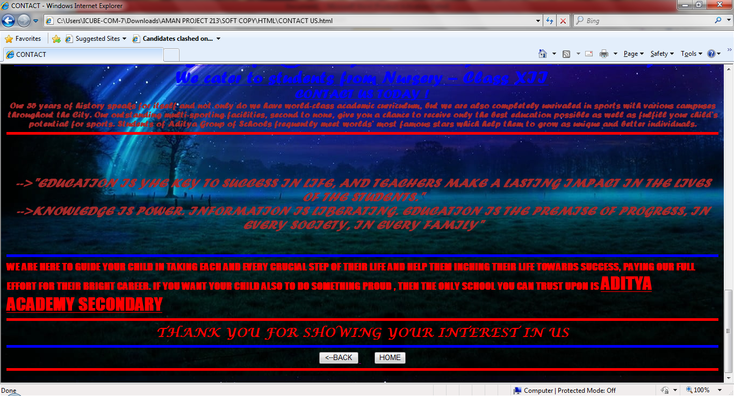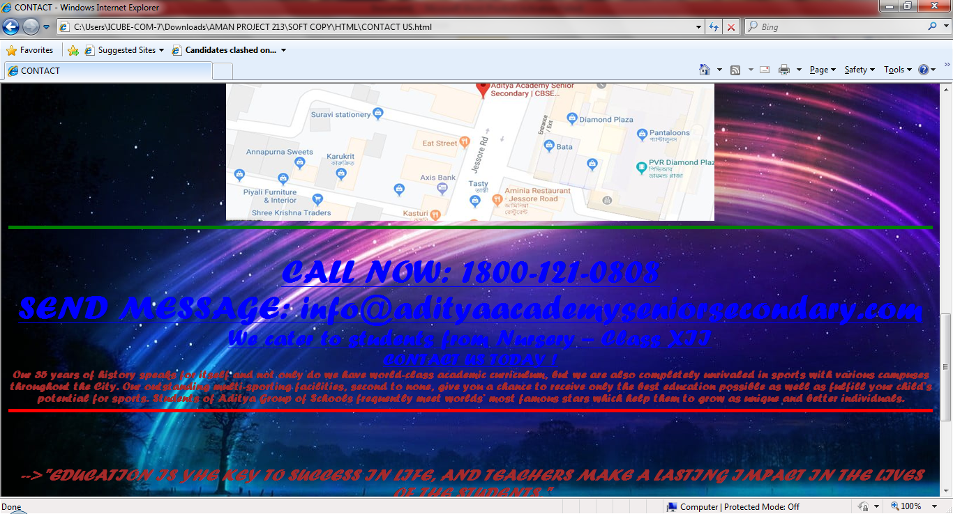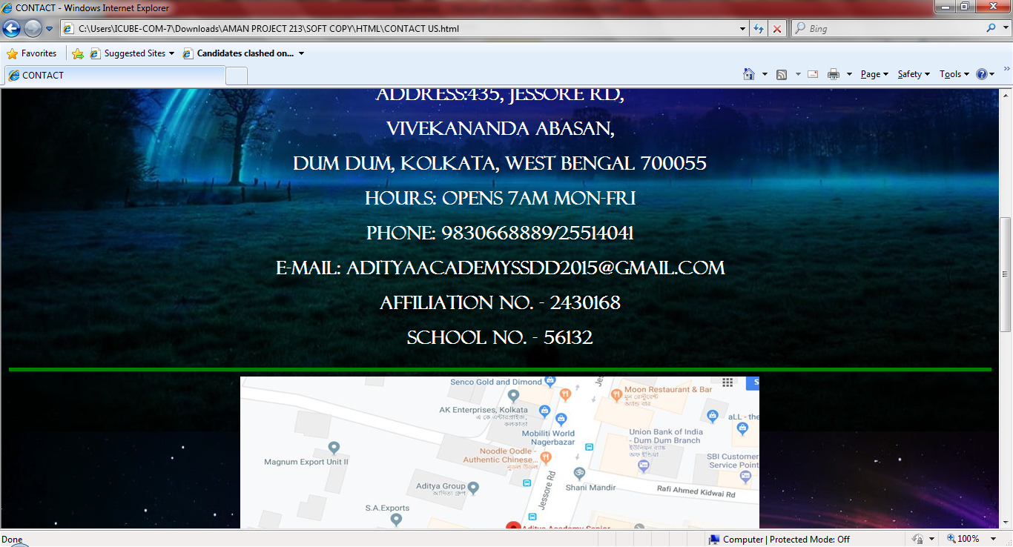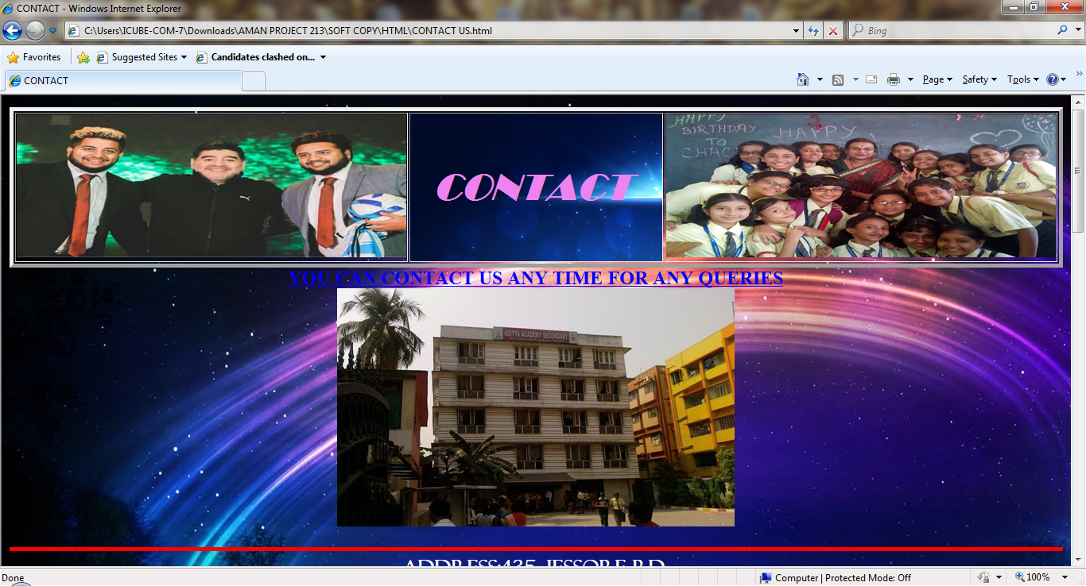

<HTML>

<TITLE>

CONTACT

</TITLE>

<HEAD>

<CENTER>

<TABLE BORDER = "5">

<TR>

<TH><IMG SRC = "d-1526645831.jpg" HEIGHT = "180" WIDTH = "490">

<TH BACKGROUND = "blue-light-sparkles-background-with-copyspace_1017-20091.JPG" BGCOLOR = "PINK" ALIGN = "CENTER" ><FONT COLOR = "VIOLET" FACE = "Broadway" SIZE = "12"><B><I>

&nbsp&nbsp&nbsp&nbsp&nbsp&nbsp&nbsp&nbsp&nbsp&nbsp

CONTACT

&nbsp&nbsp&nbsp&nbsp&nbsp&nbsp&nbsp&nbsp&nbsp&nbsp

</I></B></FONT></TH>

<TH><IMG SRC = "5aa65ba427cdb-aditya-academy-childrens-day-zedua-2.JPG" HEIGHT = "180" WIDTH = "490">

</TR>

</TABLE></CENTER>

</HEAD>

<BODY BACKGROUND = "sky-space-long-exposure-night-wallpaper.JPG">

<CENTER>

<FONT SIZE = "5" COLOR = "BLUE" FACE = "Franklin Gothic"><B><U>YOU CAN CONTACT US ANY TIME FOR ANY QUERIES</U></B></FONT><BR>

<IMG SRC = "29777-large.JPG" HEIGHT = "300" WIDTH = "500"><BR><BR><HR SIZE = "5" COLOR = "RED">

<FONT SIZE = "5" COLOR = "WHITE" FACE = "Felix Titling"><B>ADDRESS:435, Jessore Rd,<P> Vivekananda Abasan,<P> Dum Dum, Kolkata, West Bengal 700055<P>

Hours: Opens 7AM Mon-FRI<P>

Phone: 9830668889/25514041<P>

E-MAIL: adityaacademyssdd2015@gmail.com<p>

AFFILIATION NO. - 2430168<P>

SCHOOL NO. - 56132<P><HR SIZE = "5" COLOR = "green">

<imgsrc = "Capture 11.jpg" height = "400" width = "700"><HR SIZE = "5" COLOR = "GREEN"><br>

<FONT SIZE = "7" COLOR = "BLUE" FACE = "Forte"><B><U>CALL NOW:

1800-121-0808</U></B></FONT><BR>

<FONT SIZE = "7" COLOR = "BLUE" FACE = "Forte"><B><U>SEND MESSAGE:

info@adityaacademyseniorsecondary.com</U></B></FONT><BR>

<FONT SIZE = "6" COLOR = "BLUE" FACE = "Forte"><B><U>

We cater to students from Nursery – Class XII</U></B><BR>

<FONT SIZE = "5" COLOR = "BLUE" FACE = "Forte"><B><U>CONTACT US TODAY !</U></B></FONT><BR>

<FONT SIZE = "3" COLOR = "BROWN">Our 35 years of history speaks for itself and not only do we have world-class academic curriculum, but we are also completely unrivaled in sports with various campuses throughout the City. Our outstanding multi-sporting facilities, second to none, give you a chance to receive only the best education possible as well as fulfill your child’s potential for sports. Students of Aditya Group of Schools frequently meet worlds’ most famous stars which help them to grow as unique and better individuals.</FONT></CENTER><HR SIZE = "5" COLOR = "RED"><BR><BR>

<CENTER>

<FONT SIZE = "5" COLOR = "BROWN" FACE = "Forte"><B><I>

-->"EDUCATION IS YHE KEY TO SUCCESS IN LIFE, AND TEACHERS MAKE A LASTING IMPACT IN THE LIVES OF THE STUDENTS."<BR>

-->KNOWLEDGE IS POWER. INFORMATION IS LIBERATING. EDUCATION IS THE PREMISE OF PROGRESS, IN EVERY SOCIETY, IN EVERY FAMILY"</I></B></FONT></CENTER><BR>

<FONT SIZE = "4" COLOR = "RED" FACE = "IMPACT"><HR SIZE = "5" COLOR = "BLUE">

WE ARE HERE TO GUIDE YOUR CHILD IN TAKING EACH AND EVERY CRUCIAL STEP OF THEIR LIFE AND HELP THEM INCHING THEIR LIFE TOWARDS SUCCESS, PAYING OUR FULL EFFORT FOR THEIR BRIGHT CAREER. IF YOU WANT YOUR CHILD ALSO TO DO SOMETHING PROUD , THEN THE ONLY SCHOOL YOU CAN TRUST UPON IS <FONT SIZE = "6" COLOR = "RED"><U><B>ADITYA ACADEMY SECONDARY</B></U></FONT><HR SIZE = "5" COLOR = "RED">

<CENTER><FONT SIZE = "5" COLOR = "RED" FACE = "Lucida Calligraphy">THANK YOU FOR SHOWING YOUR INTEREST IN US</FONT></CENTER><HR SIZE = "5" COLOR = "BLUE">

<CENTER>

<A HREF = "ADMISSION.html">

<INPUT TYPE = "BUTTON" NAME = "S1" VALUE = "<--BACK">

</A>

&nbsp&nbsp&nbsp&nbsp&nbsp&nbsp<a href = "HOME PAGE.html"><INPUT TYPE = "BUTTON" NAME = "S2" VALUE = "HOME"></A><BR></CENTER><HR SIZE = "5" COLOR = "RED">

</BODY>

</HTML>